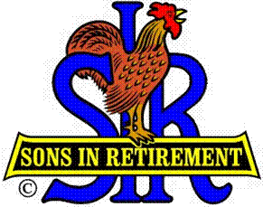

Las Trampas Branch 116

Executive Committee Meeting Agenda

October 15, 2018
9:30 AM
- Call Meeting to Order and confirm we have a quorum.
- Review Agenda/Minutes for Changes/Additions.
- Standing Reports:
Secretary – Fred Schafer: – Approval of September 17, 2018 minutes
Open Discussion
Attendance – Kevin Donahue:
Head count
Missed Luncheons
Open Discussion

Membership – Phil Goff:
New Members to be inducted: None
Guests Today: None
Visitors: None
Open Discussion

Budget – Jim Nickels:
Open Discussion

- Big Sir Report:
- OPEN SEATING and ASSIGNING OF TABLES
- Honor Past Big SIR, complimentary lunch
- Veterans Dedication for November, Pictures
- 20 Year Membership Awards: Tim Hubbard and Allen Leschot
- Open Discussion

- Little Sir Report:
- June Speaker: Morgan Galli (female), High Speed Rail System
- Innvocation: Darrell McClaughry
- Story Teller: Mac Mclloughlin
- Committee Report
- Open Discussion

- Other Reports & Discussion

- Adjourn – 10:15 am

